

Cognizance 2022

Task-4



June 20, 2022

Sayan Banerjee

CH.EN.U4CSE20064

# Part-1 Flag Hunt

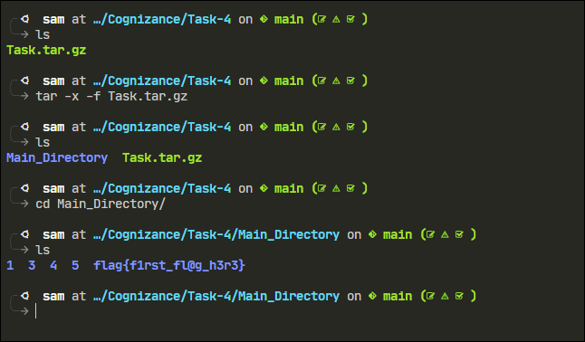

Flag 1: flag{f1rst_fl@g_h3r3}

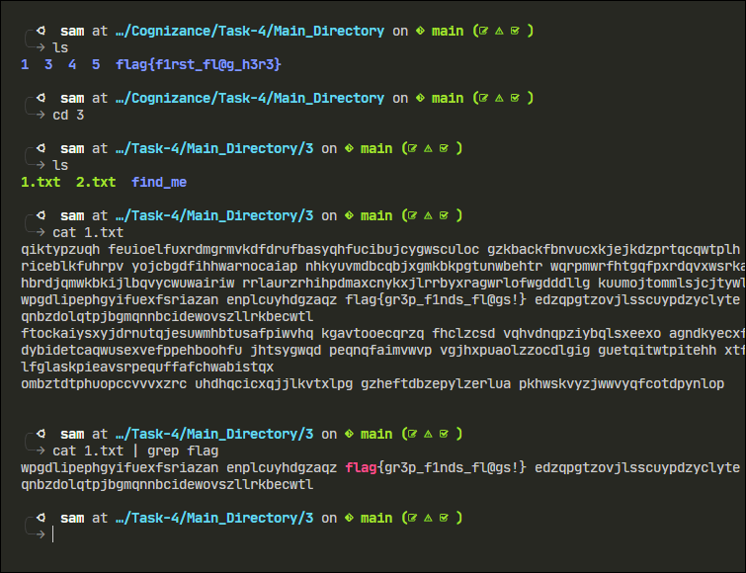

Flag 2: flag{gr3p_f1nds_fl@gs!}

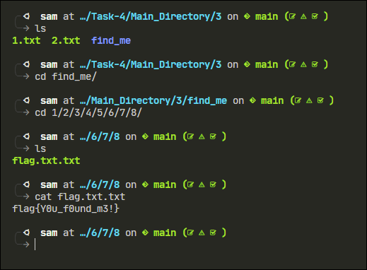

Flag 3: flag{Y0u_f0und_m3!}

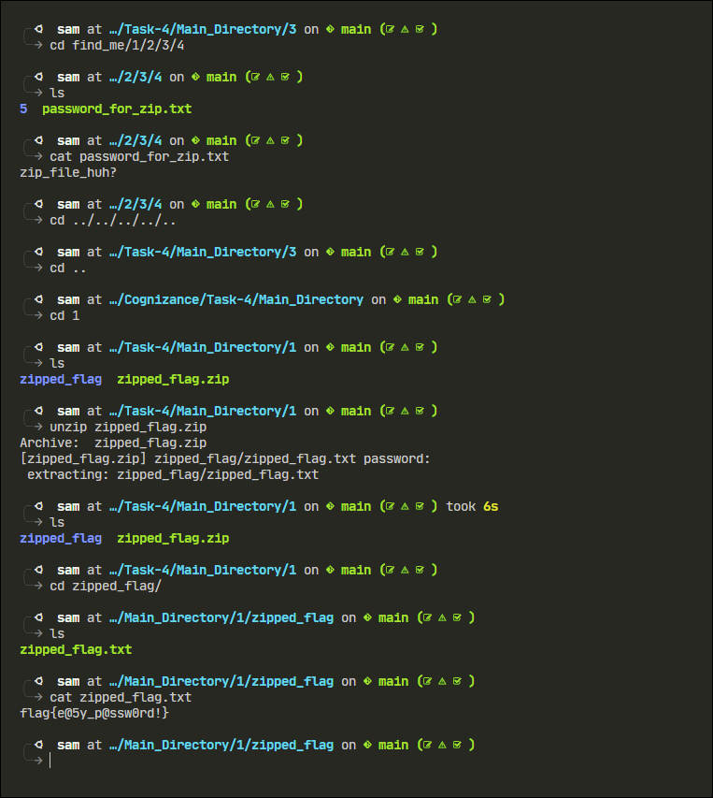

Flag 4: flag{e@5y_p@ssw0rd!}

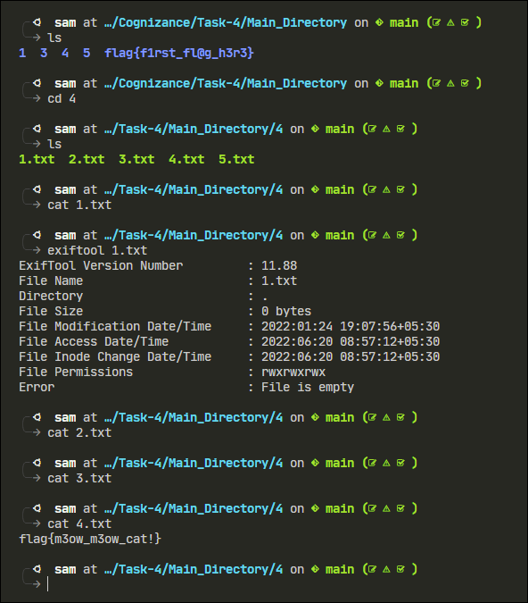

Flag 5: flag{m3ow_m3ow_cat!}

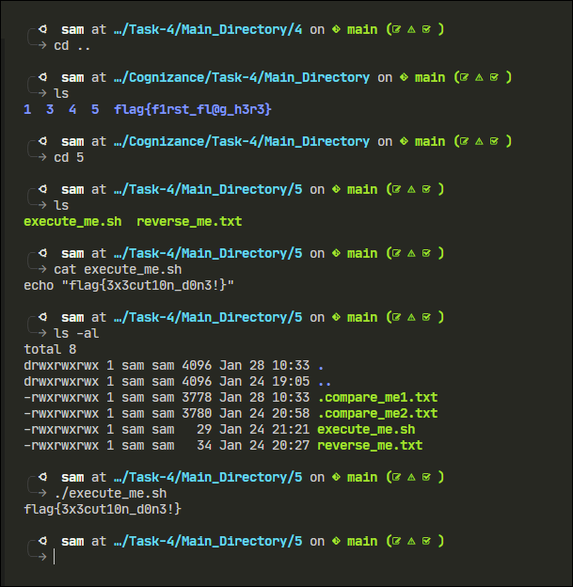

Flag 6: flag{3x3cut10n_d0n3!}

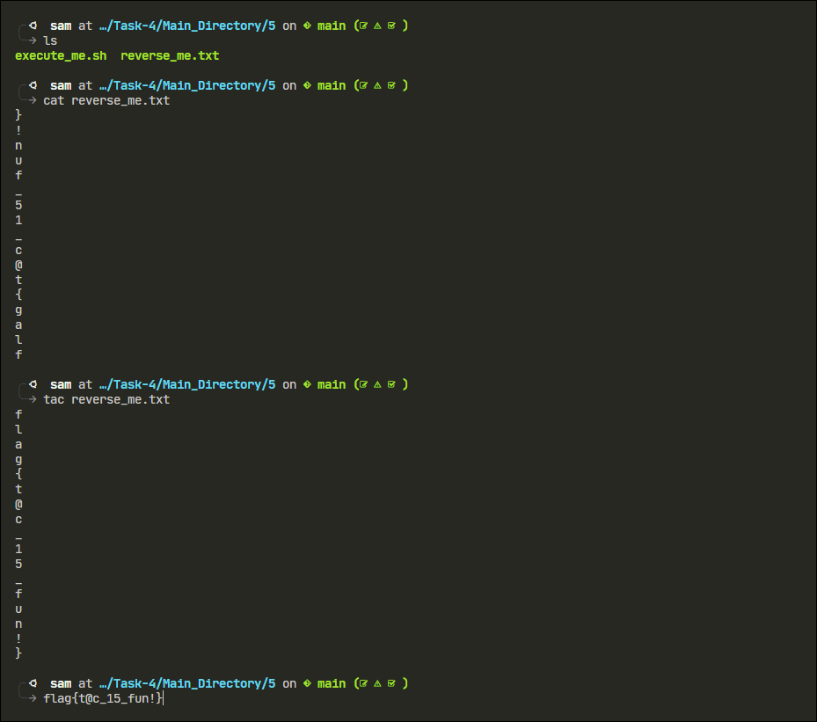

Flag 7: flag{t@c_15_fun!}

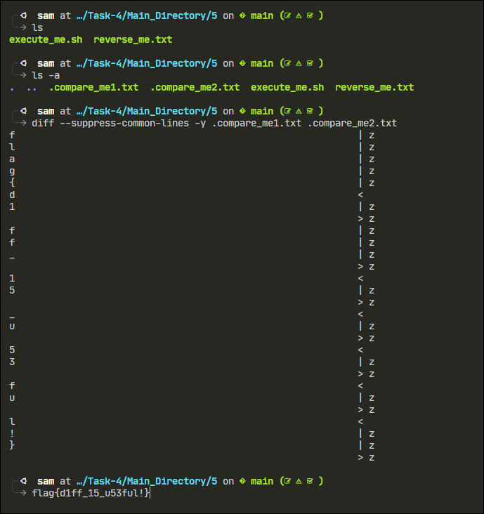

Flag 8: flag{d1ff_15_u53ful!}

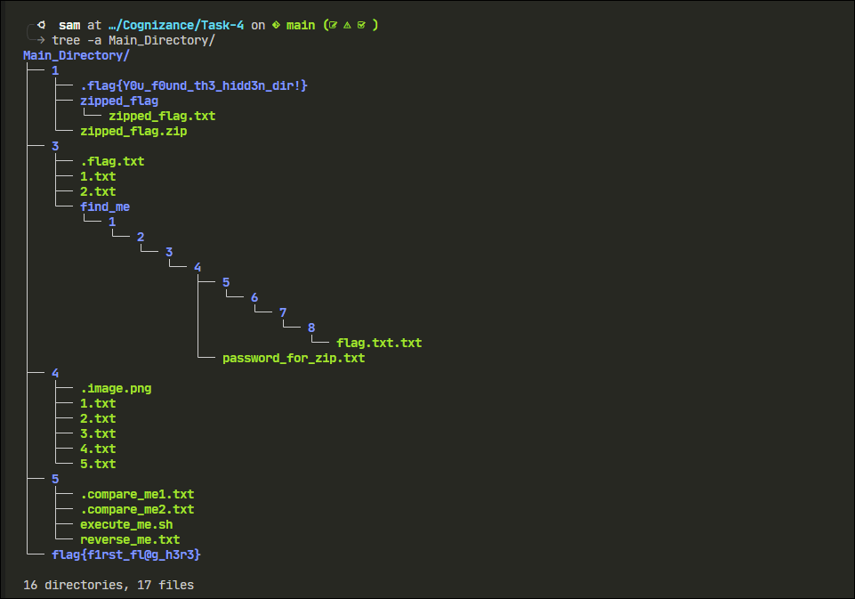

Flag 9: flag{Y0u_f0und_th3_hidd3n_dir!}

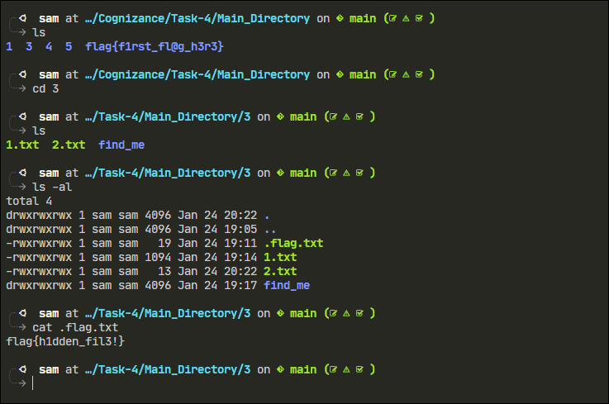

Flag 10: flag{h1dden_fil3!}

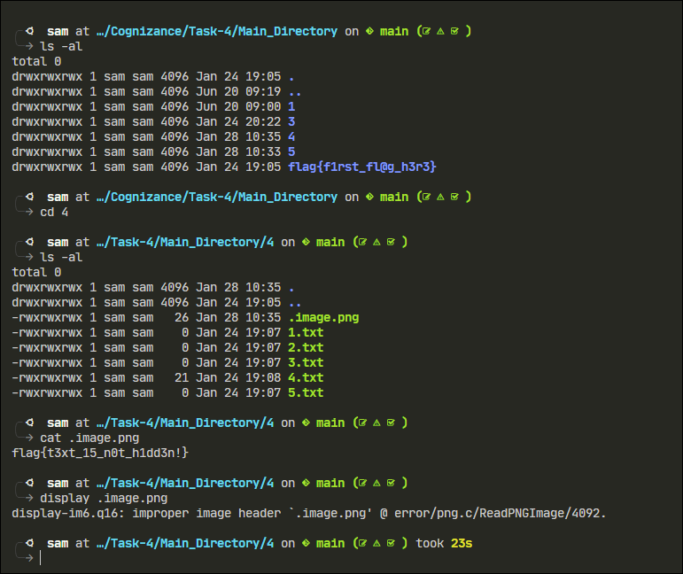

Flag 11: flag{t3xt_15_n0t_h1dd3n!}

# Part 2 – Bash Scripts

* Write a bash script to echo your name 25 times

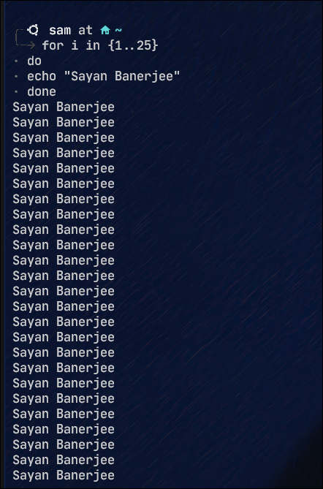

* What command should I use to display the **first** 30 entries of the Syslog file?

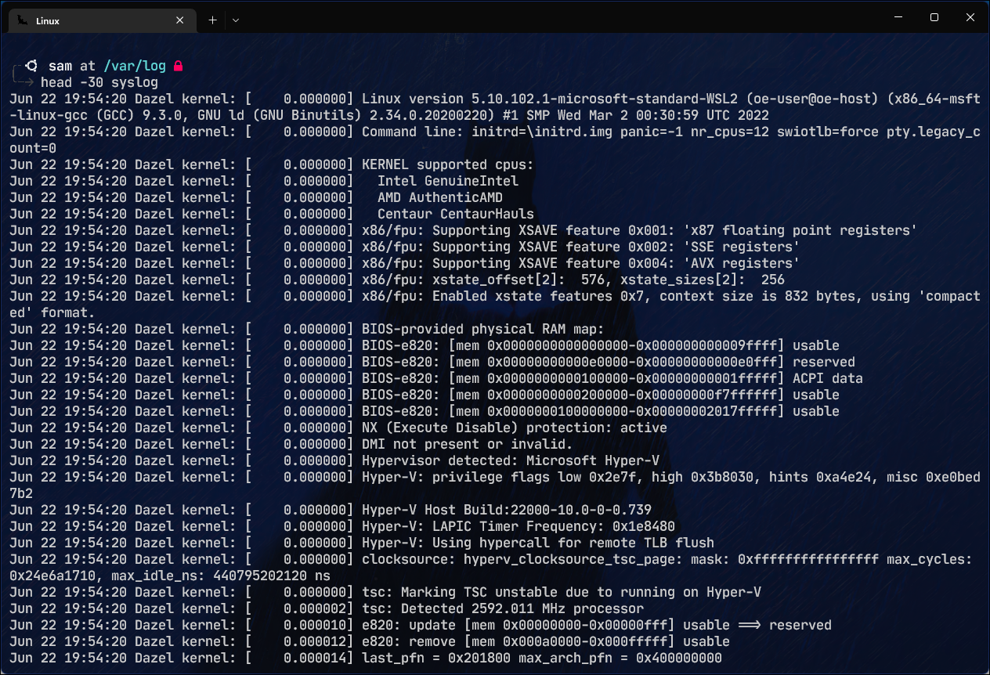

* What command should I use to display the **last** 30 entries of the Syslog file?

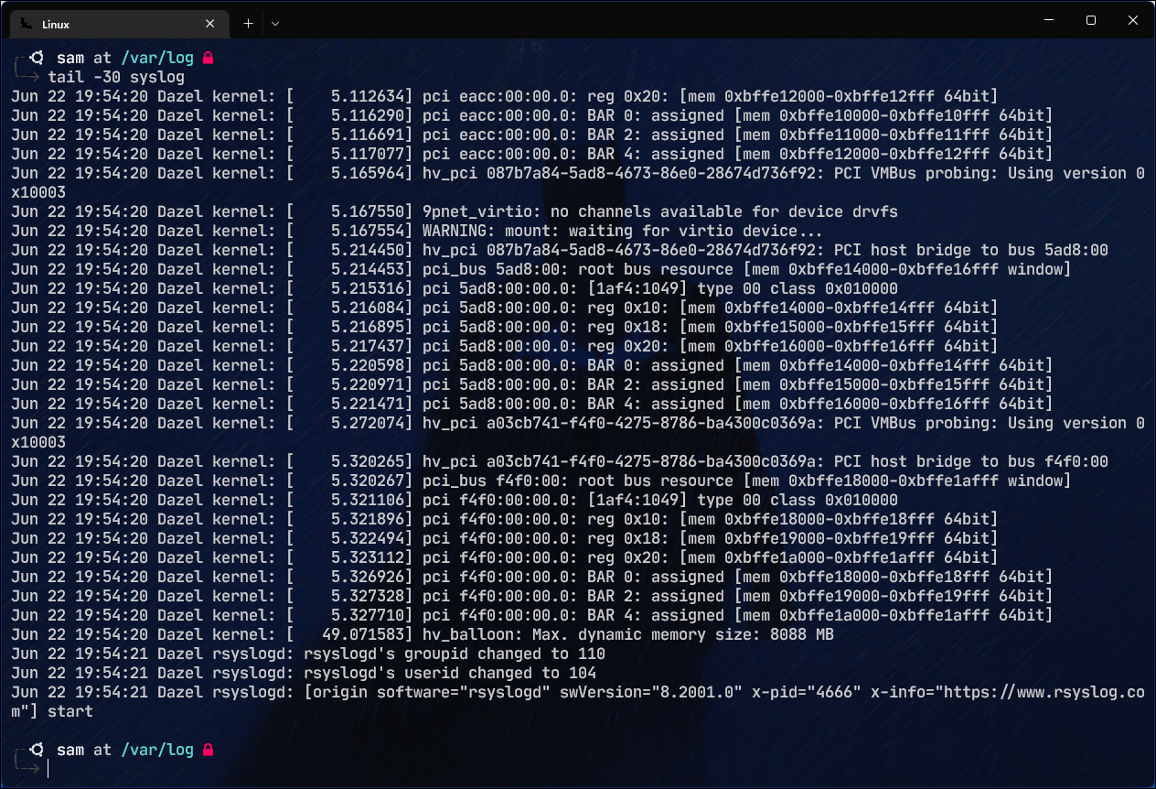

* 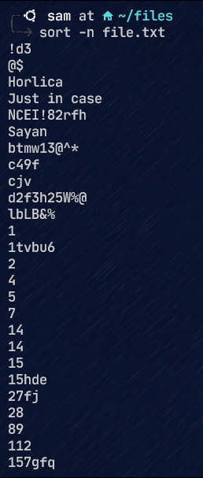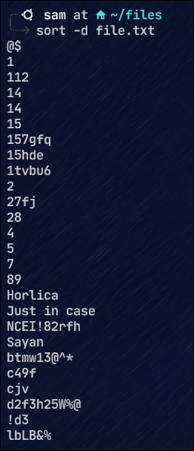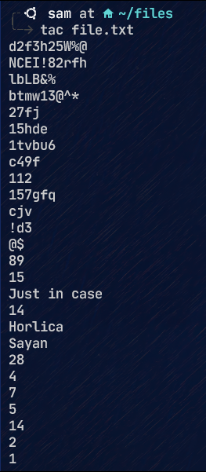What command should I use to arrange the entries of a file
  + 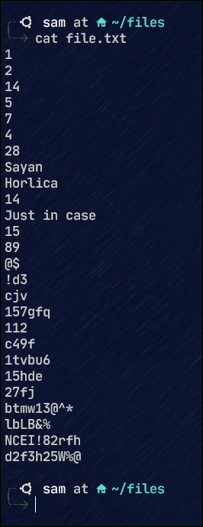Alphabetically
  + Reverse order
  + Numerical order
* Copee is a hard-working cop. He found a case and was almost on the verge of cracking it. It could be his best breakthrough. He has the list of criminals but lots of duplicates are there. He needs to find the only one that is **different.** He sought your help. How will you sort this issue?

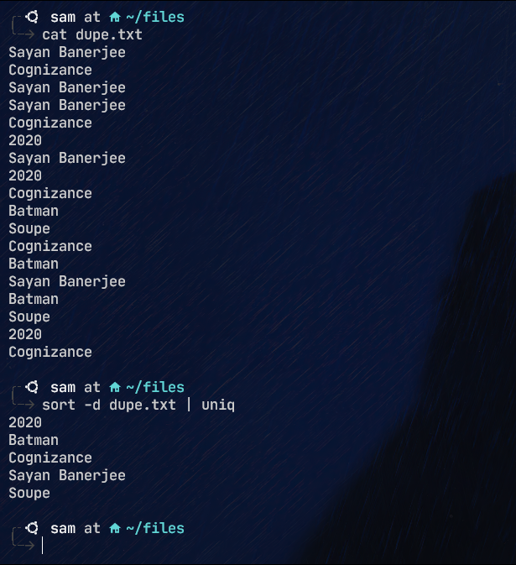

* What are the three parts of the file's permission?

Three parts of file permission are, read, write and execute. Denoted by -r for reading, -w for writing and -x for executing. They further have three groups in them, called User, Group, and Others. Where User means the current user’s access, Group means what the group has access to, and Others show what everyone else has the access to.